Domain Models

Objectives

Identify conceptual classes related to the current iteration.

Create an initial domain model.

Model appropriate attributes and associations.

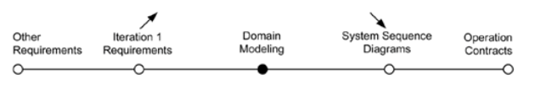

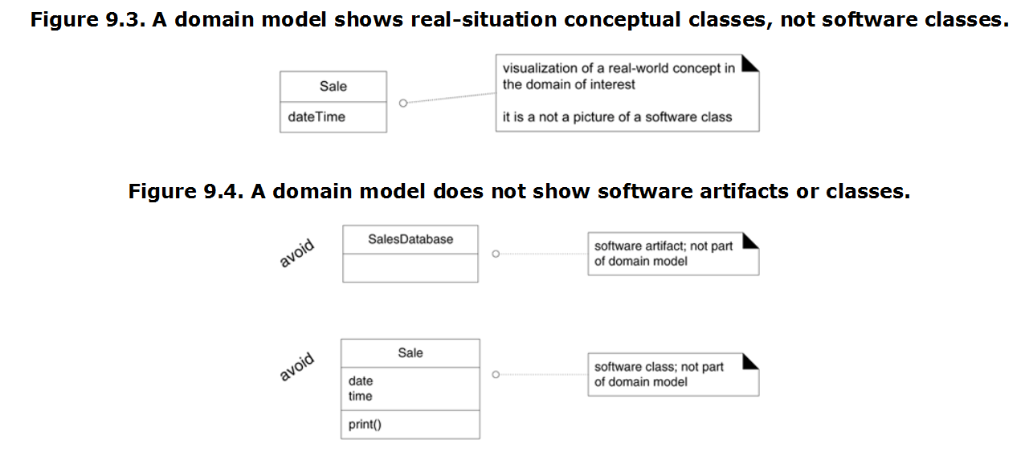

### How to Create a Domain Model?

Bounded by the current iteration requirements under design:

1. Find the conceptual classes (see a following guideline). 3 method
2. Draw them as classes in a UML class diagram.
3. Add [associations](mk:@MSITStore:D:\Pdf-Ders\GitHub\Question-Answering-Music\Raporlar\kitap\Applying.UML.and.Patterns.3rd.Edition.chm::/0131489062/ch09lev1sec15.html#ch09lev1sec15) and [attributes](mk:@MSITStore:D:\Pdf-Ders\GitHub\Question-Answering-Music\Raporlar\kitap\Applying.UML.and.Patterns.3rd.Edition.chm::/0131489062/ch09lev1sec17.html#ch09lev1sec17). See p. [149](mk:@MSITStore:D:\Pdf-Ders\GitHub\Question-Answering-Music\Raporlar\kitap\Applying.UML.and.Patterns.3rd.Edition.chm::/0131489062/ch09lev1sec15.html#ch09lev1sec15) and p. [158](mk:@MSITStore:D:\Pdf-Ders\GitHub\Question-Answering-Music\Raporlar\kitap\Applying.UML.and.Patterns.3rd.Edition.chm::/0131489062/ch09lev1sec17.html#ch09lev1sec17).